

T820**(E)**(A12)T

**NATIONAL CERTIFICATE**

# INDUSTRIAL INSTRUMENTS N5

(8080205)

**12 April 2018 (X-Paper)**

**09:00–12:00**

**This question paper consists of 7 pages and a formula sheet of 2 pages.**

## DEPARTMENT OF HIGHER EDUCATION AND TRAINING

**REPUBLIC OF SOUTH AFRICA**

NATIONAL CERTIFICATE

INDUSTRIAL INSTRUMENTS N5

TIME: 3 HOURS

MARKS: 100

### INSTRUCTIONS AND INFORMATION

1. Answer ALL the questions.

1. Read ALL the questions carefully.

1. Number the answers according to the numbering system used in this question paper.

1. Write neatly and legibly.

**SECTION A: FLOW MEASUREMENTS**

### QUESTION 1

Various options are given as possible answers to the following questions. Choose the answer and write only the letter (A–D) next to the question number (1.1–1.8) in the

ANSWER BOOK.

1.1 Bernoulli's equation is a mathematical expression of …

1. the ratio of kinetic to viscous forces in a flow stream.
2. friction loss as fluid moves through a rough pipe.
3. fluid density and compressibility in a restriction. D potential and kinetic energies in a flow stream.

1.2 Which ONE of the following flow-measuring instruments is inherently linear and does NOT require signal compensation, for example square root extraction:

1. Target flowmeter
2. Venturi tube
3. Orifice plate
4. Turbine flowmeter

1.3 As incompressible fluid moves through a restriction …

1. velocity decreases and pressure increases.
2. velocity increases and pressure increases.
3. velocity increases and pressure remains the same. D velocity increases and pressure decreases.

1.4 For accurate operation, orifice plate flowmeters require …

1. laminar flow.
2. fully developed turbulent flow.
3. swirls and eddies in the flow stream.
4. transitional flow.

1.5 Based on the relative position of a transmitter and orifice plate this flow-measuring installation is suitable for which ONE of the following types of flow:

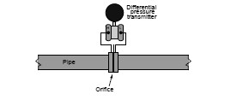

Differential

Pressure

Transmitter



O

rifice

1. Slurry flow
2. Water or oil flow
3. Gas flow
4. Steam flow

1.6 Which ONE of the following flowmeters inherently measures maximum flow rate:

1. Thermal flowmeter
2. Magnetic flowmeter
3. Flow nozzle
4. Vortex-shedding flowmeter

1.7 A magnetic flowmeter will not properly measure the flow rate of …

1. dirty water.
2. milk.
3. oil.
4. caustic.

1.8 A flag flapping in a breeze illustrates which type of dynamic fluid effects?

1. Cavitation
2. Vortex shedding
3. Transitional flow D Coriolis effect

### (8 × 1) [8] QUESTION 2

2.1 The Hungarian aeronautical engineer, Theodore von Karman (1881–1963), developed the theory behind vortex flowmeters. This meter determines the velocity of flow by a sensor counting the amount of vortices that pass it.

2.1.1 Draw a neat, labelled sketch of a vortex-shedding flowmeter. (6)

2.1.2 Give THREE applications in which vortex-shedding flowmeters are

used. (3)

2.2 Study the figure and answer the questions.

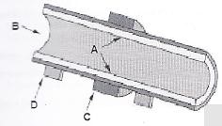

2.2.1 Identify components A–D. (4)

2.2.2 What type of thermal mass flowmeter is shown in the figure? (2)

2.3 A swirl flowmeter is a velocity-sensitive device that measures the volumetric flow of gasses and liquids.

2.3.1 Make a neat, labelled sketch of a swirl flowmeter. (6)

2.3.2 Give THREE advantages and THREE disadvantages of a swirl

flowmeter. (3 + 3) (6)

**[27]**

**TOTAL SECTION A: 35**

**SECTION B: DENSITY, HUMIDITY AND VISCOSITY MEASUREMENT**

### QUESTION 3

3.1 Explain with the aid of a fully labelled sketch the operation of a saturation

temperature hydrometer. (10)

3.2 Explain with the aid of a sketch the principle of operation of an infrared

absorption hygrometer. (10)

3.3 Make a neat, fully labelled sketch of a falling piston viscometer. (9)

**[29]**

**TOTAL SECTION B: 29**

**SECTION C: pH MEASUREMENT**

### QUESTION 4

4.1 The hydrogen ion content in water goes from 0,15 g/ℓ to 0,0025 g/ℓ.

How much does the pH change? (4)

4.2 Explain each of the following terms that apply to conductivity:

4.2.1 Conductivity cell constant (3)

4.2.2 Polarisation (3)

4.3 Show with the aid of graphs the characteristics of a pH meter measuring at

the ISO potential point. (5 × 2) (10)

### [20]

**TOTAL SECTION C: 20**

-7-

### SECTION D: AUTOMATIC CONTROL QUESTION 5

5.1 The sketch below shows a pneumatic receiver controller.

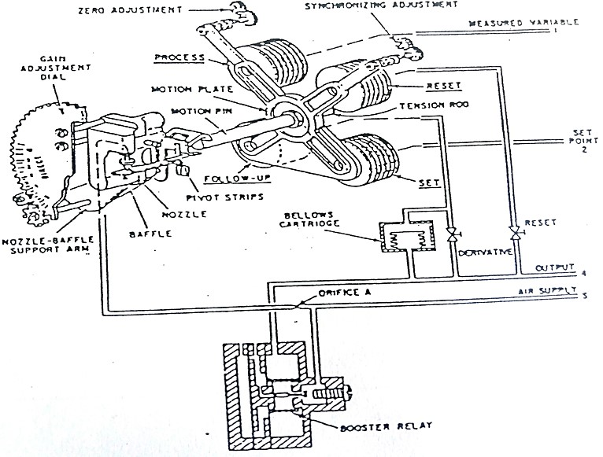

**PNEUMATIC RECEIVER CONTROLLER**

Explain each of the following in detail:

5.1.1 The condition where the controller is in balance (3)

5.1.2 The conditions if the measured variable is increased by 10 kPa –

the gain adjustment is 1,0 and NO integral or derivative action is

generated (4)

5.1.3 The proportional band of the controller if the gain setting is as in

QUESTION 5.1.2 (1)

5.1.4 The way to reverse the action of this type of controller (1)

5.2 The most commonly used circuitry or discrimination between reference and error levels is the operational amplifier.

Make a neat, labelled sketch of the differential amplifier or comparator. (4)

5.3 Name THREE forms of discrimination other than the one mentioned in

QUESTION 5.2. (3)

### [16]

**TOTAL SECTION D: 16**

**GRAND TOTAL: 100**

-1-

### FORMULA SHEET

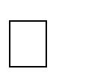W = 359 2 CZEd2 (*h*) Rd = W/15 8 µd

Q = 359 2 CZEd2 (*h*/ ) Rd = Q/15 8 µd

W = 0 01252 CZEd2 (*h*) Rd = 3 54 W/µd

Q = 0 01252 CZEd2 (*h*/ ) Rd = 3 54 Q/µd

Qg = 2 238 CZEd2 (*h*/ ) Rd = Qg/98 6 µd m = (d/D)2 E = 1/ (1*m*2)



*W Q* ()

*N*  2 (*h*)  001252 *D*2 (*h*)

001252*D*

mE = N/CZ CmE = N/Z mE = CmE/C m = (d/D)2 E = 1/ (1 *m*2)

*Rd*  *W*  *Q*  *Qg*

158*D* (*m*) 158 *D* (*m*) 986 *D* (*m*)

*N*  *W*  *Q* ()  *Qg* ()

3592 *D*2 (*h*) 3592 *D*2 (*h*) 2 238 *D*2 (*h*)

*d*/*D* [(*mE*)2/1 (*mE*)2] mE = N/CZ

W = 1 890 Ud2(*P*) for critical flow

CmE = N/Z mE = CmE/C

*d* [*W*/1890*U*(*P*)] for critical flow

*Rd*  354*W*  354*Q* *d*/*D* [(*mE*)2/1  (*mE*)2]

*D* (*m*) *D* (*m*)

*W* 1252*Ud*2(*P*) for critical flow *d* [*W*/1252*U* (*P*)] for critical flow

Please turn over

-2-

1 kPa = 102 mmWD

1 lb/ft3 = 16,0183 kg/m3

Atmospheric pressure = 101,325 kPa

Gravitation acceleration = 9,81 m/s2

For D + D/2 tappings and flange tappings:

*h kPa*

 27,2   27,2

*Pa kPa*

 8  5 *Q**B* 2*g*.*H*3

*Q* *Tan* 2*g*.*H*

15 2